John J. Coulter / Managing Director
Trendrating / 104 W. 40th Street, NEW YORK, NY 10018
U.S. Momentum outlook: general retailers experiencing ratings downgrades

About Trendrating
- Leading provider of portfolio and markets analytics based on a new generation of ‘smart’ price momentum analytics

- Developed over 8 years of breakthrough research by a successful team of experts

- Trendrating brings momentum analysis to a new level of accuracy by systematically capturing trends earlier & more robustly than legacy-based models

- Asset managers use Trendrating as a complement to their existing strategies to maximize profits and control portfolio risk

- Trendrating adds efficiency, discipline, transparency and measurability to the investment process

REPORT SUMMARY:
- As of February 21, 2017, there were 32 U.S. General Retail stocks rated “D” by Trendrating.
- While 72% of U.S. General Retailers are A or B rated, in the last month downgrades outpaced upgrades by a margin of 19 to 13.
- Downgrades were issued on February 21 for big name retailers JC Penney, Nordstrom and Williams Sonoma.
- Correctly called “D” ratings dropped 24% in price, while incorrect calls increased by just 4%.

Below is a look at Worldwide ratings for General Retailers over that past 12 months (Figure 1). You can see that the industry has maintained a steady percentage of approximately 70% of positively rated stocks over the past 8 months. U.S. General Retailers have experienced a recent predominance of downgrades over the past month, which could be a sign of a reversal for this industry. Major retailers JC Penney, Nordstrom and Williams Sonoma all were issued downgrades to “D” in the past few days.

Trendrating’s quick and accurate momentum ratings enable our clients to avoid downside capture by helping to limit their exposure to stocks in sectors and industries with negative ratings. Our model was designed to identify trend reversals early to systematically let you exit losing positions sooner to manage portfolio risk. If you look at the attached charts of “D” rated stocks, you will see how well Trendrating spots negative momentum.

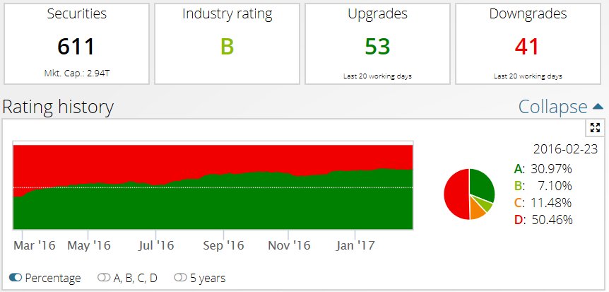
Figure 1- General Retailers Globally Could Be Trending into Negative Momentum as U.S. Has More Downgrades than Upgrades
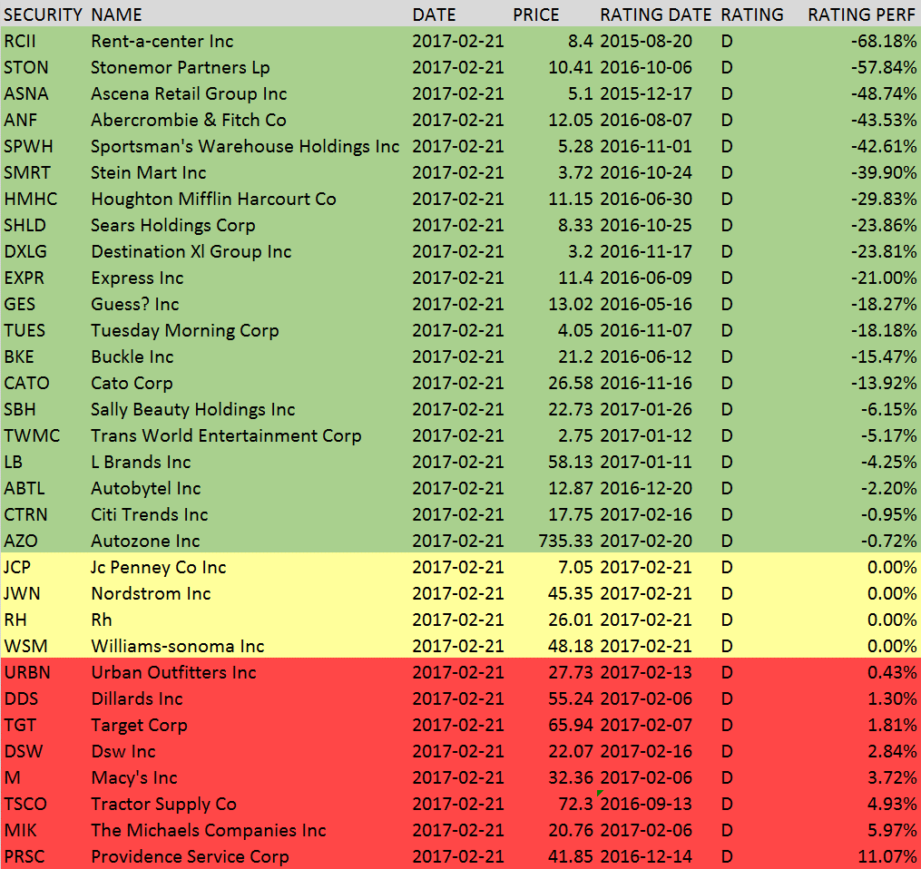
Figure 2 – There are currently 32 U.S. General Retailer Stocks rated “D” by Trendrating

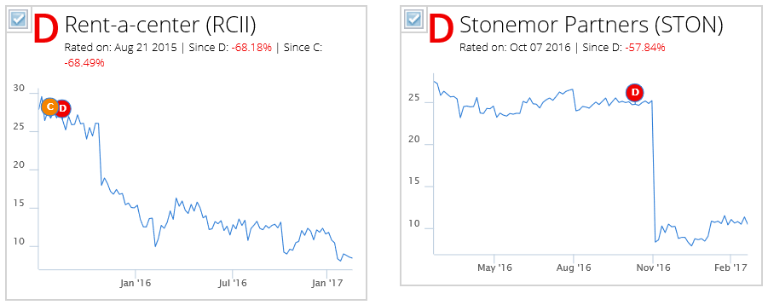
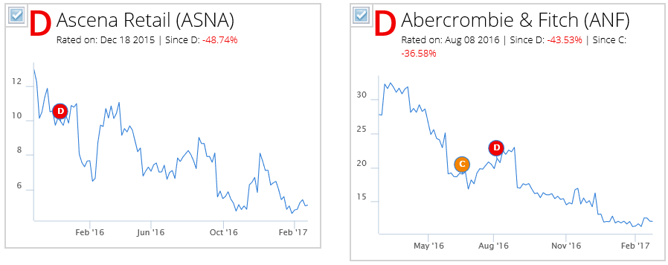

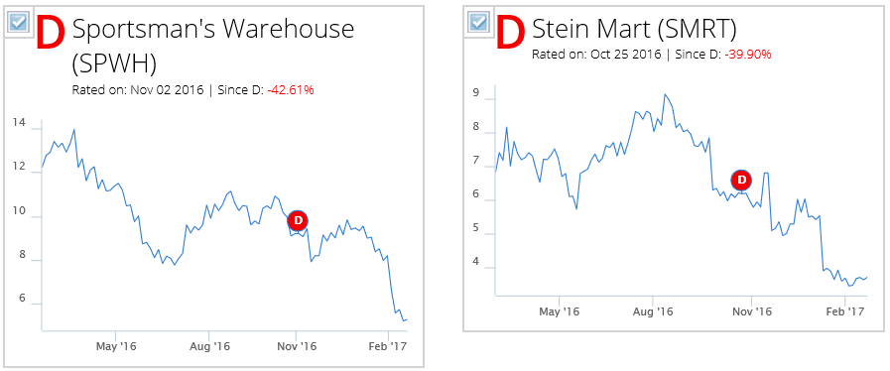
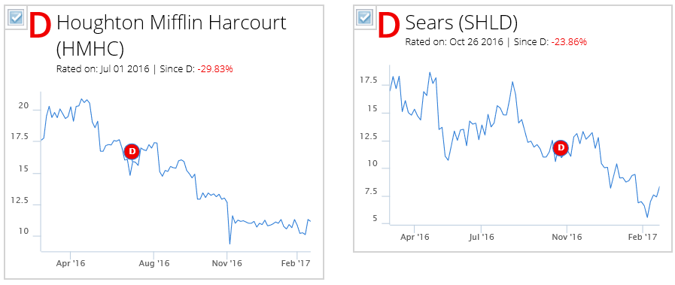

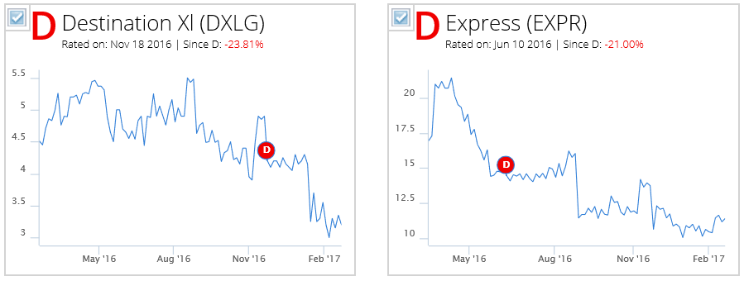

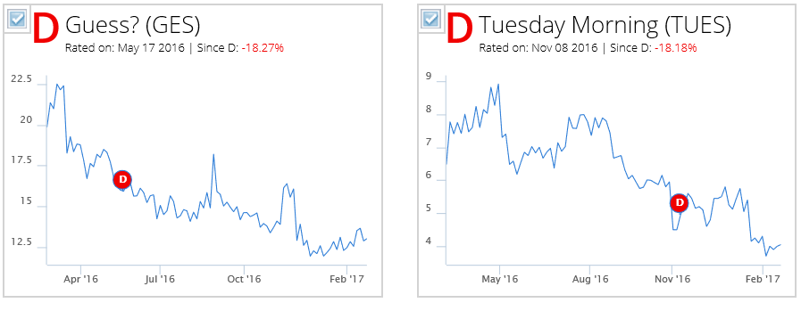

Using the Trendrating Strategy Builder, you can create a systematic way to invest in the highest rated stocks or ETFs using either an Alpha (stock/ETF selection) or Smart Beta (fully invested in all constituents of an Index) approach. In the Alpha strategy we created below, we invested in US General Retailer stocks applying the following parameters:

Ratings Selection: A or B
Holding Rules: 20 stocks, Fully Invested, Max weight cap of 5%
Rebalance: Quarterly, Give priority to A ratings & Higher performance since rated
Benchmark: S&P 500 Consumer Services Index

Had you followed this strategy over the past eight years, you would have added over 6% of Alpha with a reasonable annual turnover of 90%.

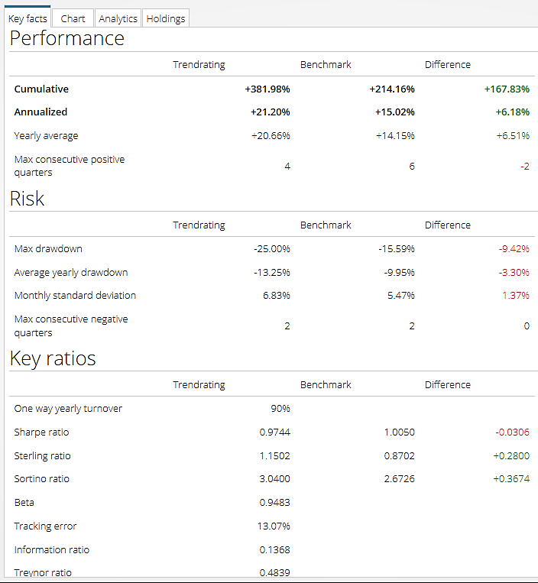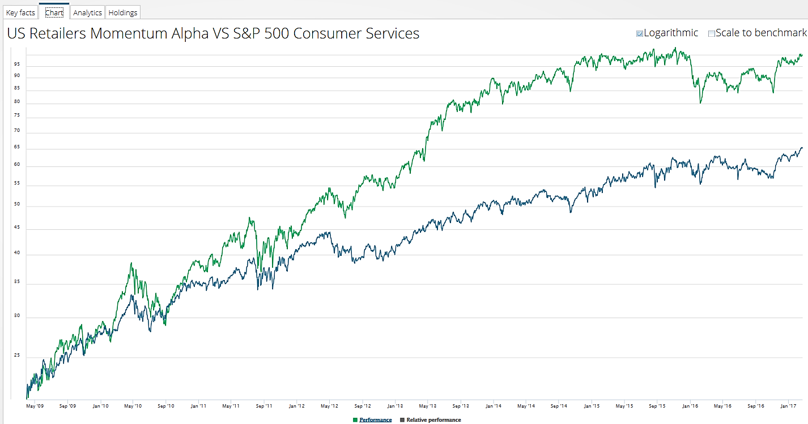

WHY YOUR FIRM NEEDS TO INCORPORATE TRENDRATING NOW

- Portfolio managers understand that their investment strategies and decision-making can be enhanced by data analysis in four key areas: to balance emotion, bias, market knowledge and opinion subjectivity.

- A growing trend sees investors incorporating systematic models which, rather than replacing experts, can be overlaid onto the existing investment decision making process.

- On average, sound models outperform experts, while adding discipline, transparency and measurability.

- Momentum is a strong factor, persistent over time and negatively correlated to most fundamental strategies.

- Momentum when combined with a value approach, can dramatically enhance returns and reduce volatility.

- Trendrating more than pays for itself by managing portfolio risk and avoiding major losses.

Contact Trendrating today to schedule a demonstration and see how our system spots major trends better than any analytics solution commercially available.
request@trendrating.com
www.trendrating.com

The evaluations, rankings and information provided by Trendrating (the "Services") are provided solely for the use of finance professionals (the "Users") who have been issued a license to use the Services by Trendrating and who, by nature of their status as investment professions understand, or are expected to understand, the complexity of finance products, the functioning of the markets and the risks inherent in them. The Services are not offered for use by persons not employed or actively working as professionals in the finance and investment industry. The Services are to be used entirely at the risk of the Users. Included in the Services are forward-looking statements that are based on observations, assumptions and calculations that reflect Trendrating's expectations. Forward-looking statements are subject to numerous risks and uncertainties that could cause actual results to materially differ from those expectations. The Services are not intended to constitute a recommendation of any specific security or financial product and are to be implemented solely in conjunction with or as part of a complete investment evaluation conducted by the Users. Under no circumstances shall Trendrating, its officers, directors, employees or agents be liable for any damages, lost profits or investment losses that result in any way from use of the Services or any interruptions, errors or delays in the Services. Trendrating S.A. © 2013-2017. All rights reserved.

